SN7402

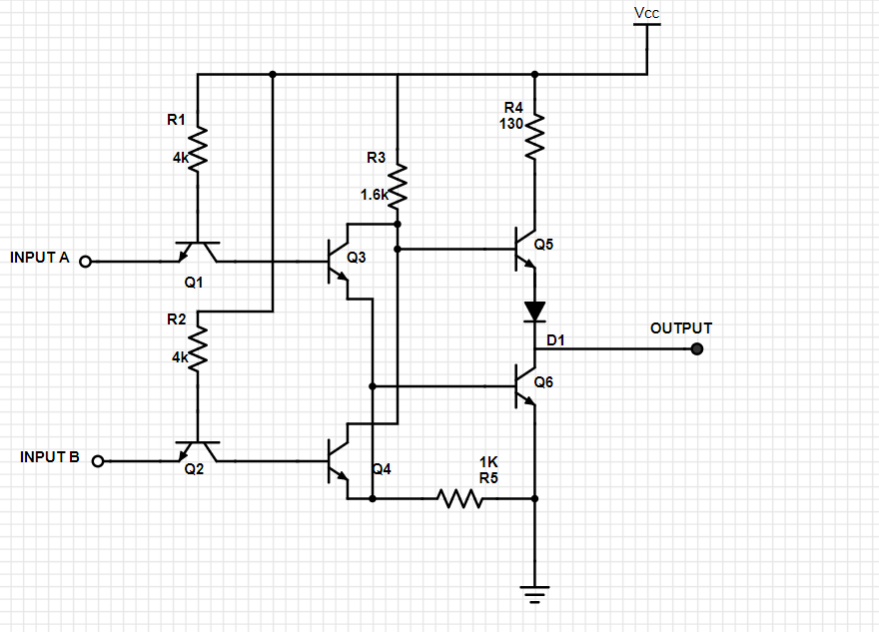

TEMA 2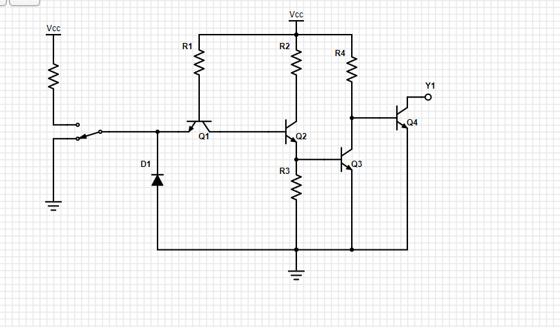

|  |  |  |  |  |  |  |
| --- | --- | --- | --- | --- | --- | --- |
| A | D1 | Q1 | Q2 | Q3 | Q4 | Y |
| L | OFF | OFF | OFF | OFF | OFF | L |
| H | ON | ON | ON | ON | ON | H |

TEMA 3



|  |  |  |  |  |  |  |  |  |
| --- | --- | --- | --- | --- | --- | --- | --- | --- |
| A | B | Q1 | Q2 | Q3 | Q4 | Q5 | Q6 | Y |
| L | L | ON | ON | ON | ON | ON | OFF | H |
| L | H | ON | OFF | ON | OFF | ON | ON | L |
| H | L | OFF | ON | OFF | ON | OFF | ON | L |
| H | H | OFF | OFF | OFF | OFF | OFF | ON | L |